Michael | The introduction to chapter 10, “Complexity,” states, “Mathematical complexity theory, which is based on fractal geometry, provides a way to measure the computational embedded in physical structures, rather than just symbolic systems.” (pg. 151). This helps me to further frame how go about studying the material, in material-semiotic analyses. And how can we use this type of analysis in the 21st century learning arena, which tends to favor computer learning, yet maintains problems of access and participation? Placing this quote in conversation with African Fractals in Math Education section of chapter 14, offer some insights to this question. The section rightly points out that with computers in schools, specifically in this case with African American students, it is not just a problem of access but also “style of utilization.” (223). I read this, utilization, as what DML researchers refers to as participation. Perhaps, however, using mathematical complexity theory to find computation in material structures provides a low-cost way to teach 21st century computing skills in schools that do not have the immediate access. If we favor utilization/participation as the primary goal of 21st century education, can we facilitate computational learning and the acquisition of new media literacies without computers?  Also, there has to be some potential research avenues on the YouTube Mandelbrot set zooms. Who creates these and why? What about YouTube user reception? What is up with users invoking kinds of religiosity in the comments sections?  http://www.youtube.com/watch?v=0jGaio87u3A&feature=related  Cool Art!  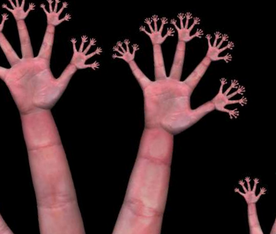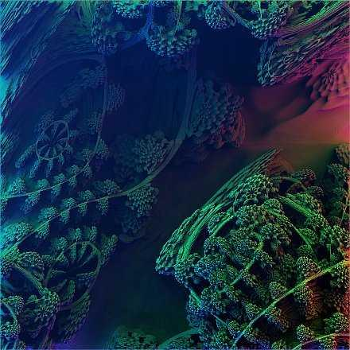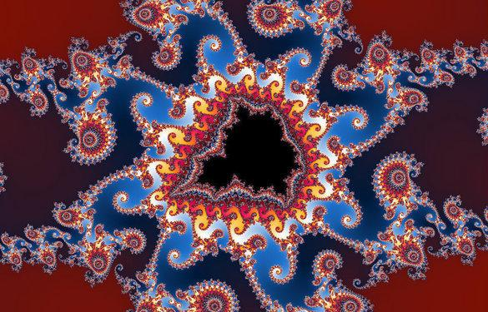
db | 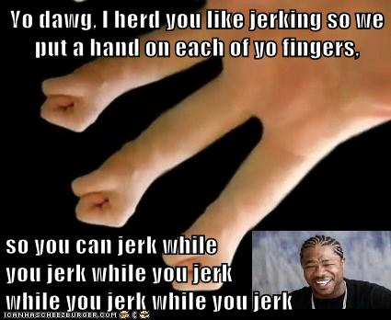^^^^ This creepy image makes it very difficult to write. (Listening to Brian Eno as I write this.) Good ole African Fractals. Recursion, rightly, gets a long chapter and a thorough treatment because it is both “the engine” of fractals but also a very prevalent form of artistic and narrative expression in native cultures. I think we see a lot of iteration in memes. Memes do a lot of linguistic work and are a difficult force to control.  From Speaking in Memes: “The definition of meme can be debated, but the short of it is that a meme is a unit of culture, a parallel to the biological gene in Richard Dawkins’s original coinage. Many have since adapted the term to describe how cultural products pass virally from person to person by multiplying themselves throughout the social body. Technically, any shared image is a meme regardless of how viral it has become, but when we say meme, we generally mean a successful one.”  This deeply biological metaphor is apt since, as Eglash shows many of the fractals seen in cultural artifacts are abstractions and generalizations (not just modeling) of natural phenomena. (Ram’s horns, ferns etc.) Self-generating, self-referential systems are at the heart (or perhaps lungs is more apt) of many natural systems. Memes then, are not only “viral” in their reproduction habits, but also convey self-referencing and deeply recursive “unit of culture.” The most straightforward example of this are the Xzibit memes:  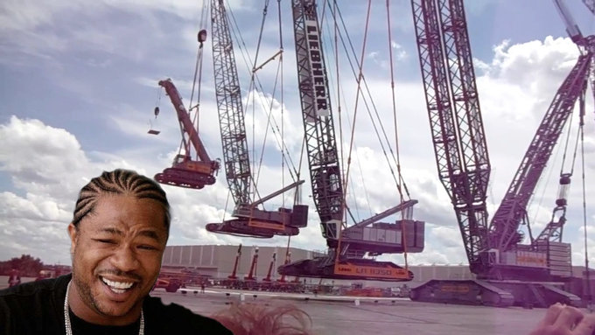    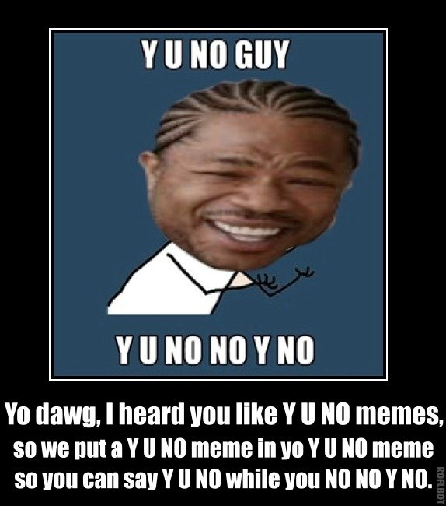  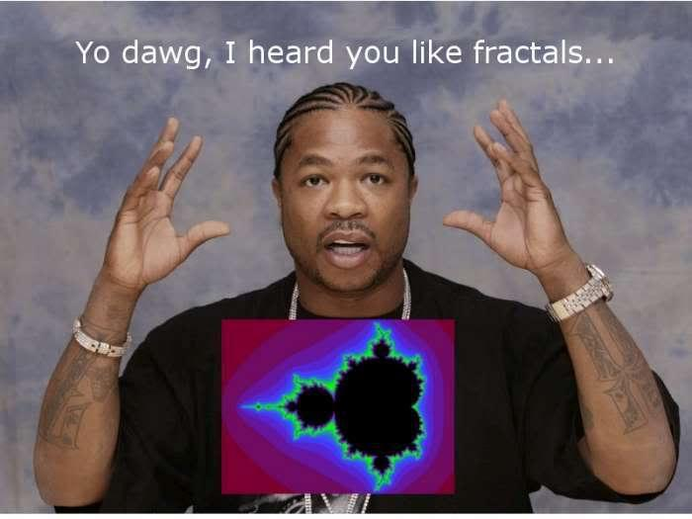
Jalynn | I like the direction of what the book appears to be trying to do on the surface. The symbols, art, and designs of various cultures might have a lot more historical meaning than what we know presently to date. Even then, the actual people themselves with knowledge of these cultural heritages probably have a lot more to say. The mathematical representations of symmetry and geometry are also things from which these unique peoples have something share.
Ellen | So, I have to say, I’m a sucker for “geomancy,” or as I should call it cedena, mainly as straddling the interesting intersection between the mathematical/scientific and the divine. Of course, when you go into a museum, devices possibly used for such divination are categorized under religious tools, but what a particularly meticulous calculation! I actually once wrote a paper about how these devices should possibly be recategorized and how museum labeling and what they emphasize can be misleading...anyway, it’s also always great to hear about two recursion nerds geeking out together.  Then the implications of the base-2 system within cedena that was carried over into European “geomancy,” which later influenced Leibniz and then made its way into binary code utilized in computing systems is fascinating. Eno’s comment about computers is funny.  Maybe this is a jump, but this leads me a to arguments against the idea of ‘primitive’ and Hooks reaction to romantic organicism on page 194  “This discourse created the idea of ‘primitive’ and promoted the notion of an ‘authentic’ experience, seeing as ‘natural’ those expressions of black life which conformed to a pre-existing pattern or stereotype.”  Also the description of rap music as a technocultural rebellion is relevant and leads me to think of Detroit, which is considered by some as the birth-place of techno as Detroit Techno originator musicians were taking minimal and simple beats to create complex, very technical, and digital music. In so far as a technocultural rebellion, perhaps Underground Resistance would be relevant? No/Yes?  http://en.wikipedia.org/wiki/Underground_Resistance_%28band%29  http://createdigitalmusic.com/2011/06/future-shock-the-emergence-of-detroit-techno-told-by-wax-poetics/  http://youtu.be/M0LbMQTvlBU?t=1m45s  Of course, I also found the recursive cosmology, going back to the womb conception interesting, because anything involving cosmology gets me psyched.  http://www.everythingisaremix.info/watch-the-series/
Pedro | -Why did Ron choose to use a spectrum of intentionality, rather than rely on other concepts that (in at least some of the middle cases) others may have chosen, like habitus?  -I thought it might be interesting to talk about voting districts and the relationship between geometry and geography.  -I really liked the paragraph beginning on the end of pg. 214.
Colin | Are we in fractal dimension 2 yet? ...  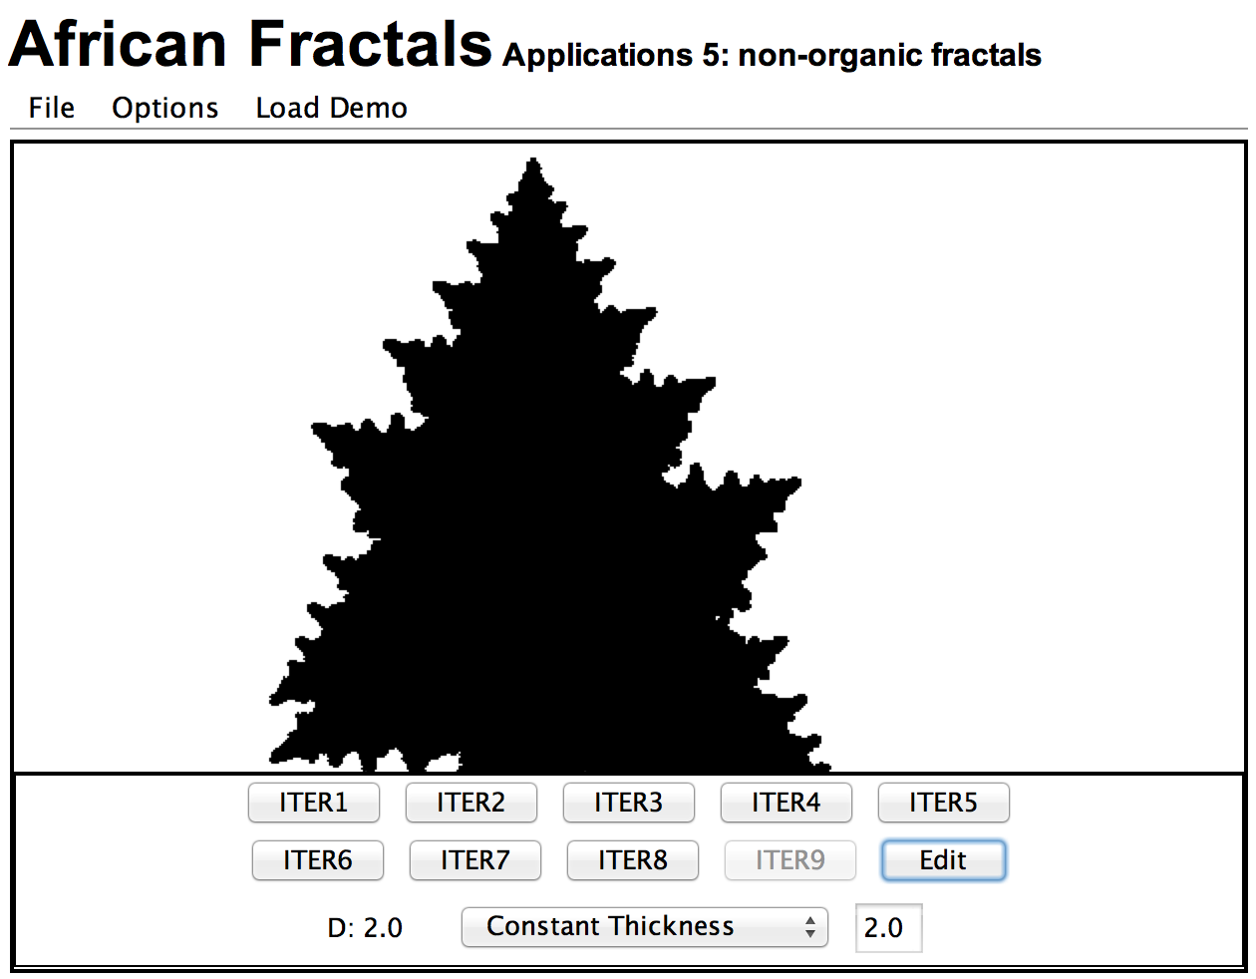  What about this?  So the claim of Leibniz’s being inspired to “discover” binary code has also been claimed by the Asian Studies people as a point for them. Their case is pretty strong: Leibniz was a Sinologist, (proto-asian studies person) and the I Ching is pure binary -- not much of a stretch.  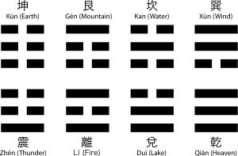  What is behind the impetus to show non-Western origins for “Western” mathematics?  On a slight departure, (but perhaps more important point for me) what are fractals really important?  What is the significance of their prevalence in Africa? Is this just a design motif? But if Ron’s intention is explicitly not to imply Africa is closer to nature -- then what?
Dan | Chapter 6 in particular is interesting to me because where I confront recursion the most is when thinking about social organizations. In particular, I think of representative government (Groups picking a member to represent the group which in term picks a member to represent the group) which is one sort of seed shape, and consensus process where in one strategy where a large group can be thought as a groupings of affinities which have affinities within them. Those large groups then attach to regional organizations that then have similar relationships. In the ideal, there is self-similar relationships in terms of what each group does scale to scale to scale. However, in practice, it's better to think of the social dynamics of larger scale groups being related to seed pattern behavior at lower levels. For example, if you've got male dominated smaller groups, it is likely to see that social relationship brought higher up into more complex systems. But the problem of recursion in these complex situation are also it's solution as, "These examples fall into two categories. In conformal mapping, the pattern simply fits along the contours of a concrete, preexisting structure." (p. 81) In one respect, we can ask ourselves to think of political organization in how much it relates to this conformal mapping and empowers people in large organizations in a way that top-down organizations do not. In the consensus model the scales up into larger groups, the ability to shift the dynamics at one scale empowers individuals to shift power relations at high levels.

